Web Wallet
# Source: AI Source: Provided by: [Data Path: Persons Table -> ID Column: 1, Name_En Column: Motasem Essam] -> From: [ChatGPT] on [1/21/2026]
A Web Wallet is a type of hot crypto wallet that is accessed through a web browser, allowing users to send, receive, and store cryptocurrencies online. It is hosted on the cloud and managed either by the user (non-custodial) or a third-party provider (custodial).

🌐 Key Characteristics of Web Wallets:
# Source: AI Source: Provided by: [Data Path: Persons Table -> ID Column: 1, Name_En Column: Motasem Essam] -> From: [ChatGPT] on [1/21/2026]
- Accessible via Browser
  - No installation required; accessible from any internet-connected device using a browser.
- Cloud-Based
  - Wallet information (including keys, in custodial setups) is stored on remote servers.
- Custodial or Non-Custodial
  - Custodial: Wallet provider holds the private keys (e.g., Binance, Coinbase).
  - Non-Custodial: User controls the private keys (e.g., Blockchain.com, MetaMask Web).
- Multi-Device Support
  - Can be accessed from PCs, tablets, smartphones, etc.

💼 Examples of Web Wallets:
# Source: AI Source: Provided by: [Data Path: Persons Table -> ID Column: 1, Name_En Column: Motasem Essam] -> From: [ChatGPT] on [1/21/2026]
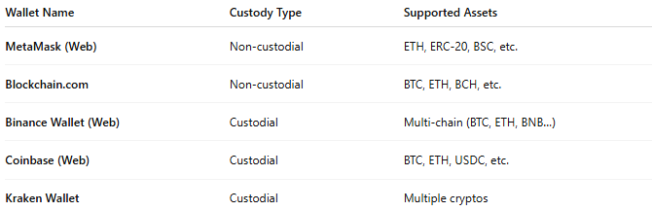

Wallet Name | Custody Type | Supported Assets
MetaMask (Web) | Non-custodial | ETH, ERC-20, BSC, etc.
Blockchain.com | Non-custodial | BTC, ETH, BCH, etc.
Binance Wallet (Web) | Custodial | Multi-chain (BTC, ETH, BNB…)
Coinbase (Web) | Custodial | BTC, ETH, USDC, etc.
Kraken Wallet | Custodial | Multiple cryptos

🛠️ How It Works:
# Source: AI Source: Provided by: [Data Path: Persons Table -> ID Column: 1, Name_En Column: Motasem Essam] -> From: [ChatGPT] on [1/21/2026]
- User creates an account on the provider’s website.
- Wallet is either generated in-browser (non-custodial) or issued by the provider (custodial).
- User can:
  - View balances
  - Send/receive crypto
  - Trade, swap, or stake (depending on platform features)
- Transactions are signed either in-browser (user-controlled) or server-side (custodial).

✅ Advantages:
# Source: AI Source: Provided by: [Data Path: Persons Table -> ID Column: 1, Name_En Column: Motasem Essam] -> From: [ChatGPT] on [1/21/2026]
- Easy to access from anywhere
- No installation required
- Often comes with exchange integration for quick trades
- User-friendly for beginners
- Many support DeFi, NFTs, and DApps via browser extensions

⚠️ Disadvantages:
# Source: AI Source: Provided by: [Data Path: Persons Table -> ID Column: 1, Name_En Column: Motasem Essam] -> From: [ChatGPT] on [1/21/2026]
- Exposed to online threats (phishing, keylogging, malware)
- Custodial wallets mean users don't control their private keys
- Risk of service downtime or platform hacks
- Depends on provider’s security policies and practices

🧠 Best Use Cases:
# Source: AI Source: Provided by: [Data Path: Persons Table -> ID Column: 1, Name_En Column: Motasem Essam] -> From: [ChatGPT] on [1/21/2026]
- Beginner-friendly crypto access
- Light crypto users who trade occasionally
- Users interacting with Web3 apps, DeFi, and NFTs
- Quick, cross-device access to crypto

🆚 Comparison with Other Wallets:
# Source: AI Source: Provided by: [Data Path: Persons Table -> ID Column: 1, Name_En Column: Motasem Essam] -> From: [ChatGPT] on [1/21/2026]
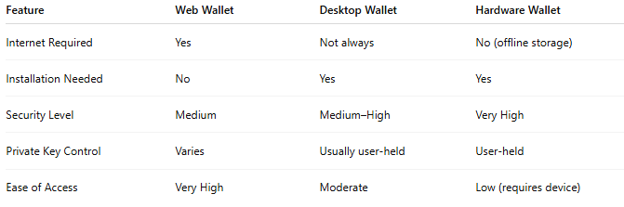

Feature | Web Wallet | Desktop Wallet | Hardware Wallet
Internet Required | Yes | Not always | No (offline storage)
Installation Needed | No | Yes | Yes
Security Level | Medium | Medium–High | Very High
Private Key Control | Varies | Usually user-held | User-held
Ease of Access | Very High | Moderate | Low (requires device)

🔐 Security Tips for Web Wallets:
# Source: AI Source: Provided by: [Data Path: Persons Table -> ID Column: 1, Name_En Column: Motasem Essam] -> From: [ChatGPT] on [1/21/2026]
- Use strong, unique passwords and 2FA
- Avoid accessing wallets on public or shared devices
- Bookmark the official site to avoid phishing
- For non-custodial wallets, back up your seed phrase securely

